12 August 2024

**SURVEY**  
**CONSUMER PARTICIPATION SOUGHT FOR A SURVEY ON ATTITUDES TO RESPIRATORY SAMPLE COLLECTION AND DEVELOPMENT OF DIGITAL HEALTHCARE TECHNOLOGIES TO IMPROVE THIER ANALYSIS**

We are seeking adults living with respiratory disease and guardians of children living with respiratory disease to participate in a survey, which seeks to understand how analyses of cells in biological samples like sputum could be improved to benefit the clinical management of respiratory diseases.

We would greatly appreciate you taking ~ 10 minutes to complete the short, multiple-choice survey. Responses will help gauge current attitudes and identify major consumer themes to improve the use of respiratory samples and lead to better health outcomes.

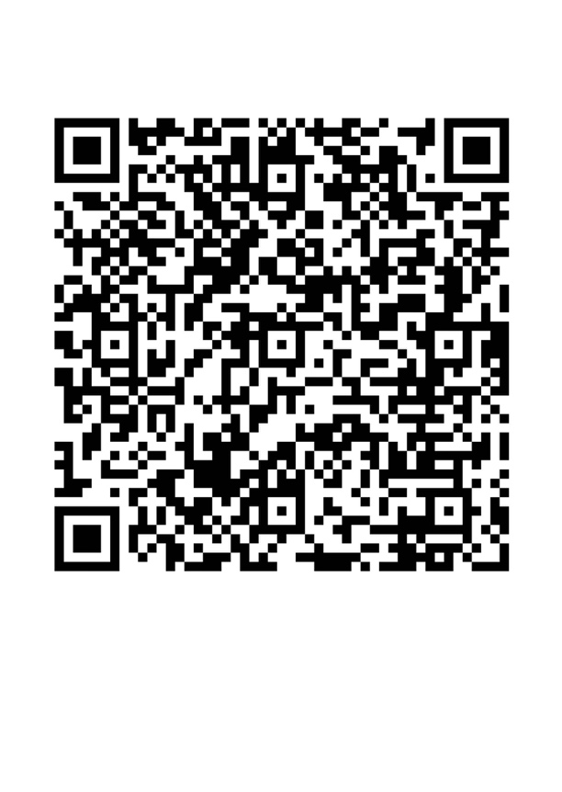

<https://redcap.telethonkids.org.au/redcap/surveys/?s=KDWT3H7N97DRX39X> or QR code above.  
  
This survey is completely anonymous. We will seek to publish survey data from this project within a respiratory journal.  
  
Approval to conduct this research has been provided by the University of Western Australia, in accordance with its ethics review and approval procedures. If you would like to discuss any aspect of this study please feel free to contact Dr Luke Garratt at luke.garratt@uwa.edu.au.  
  
Please share this invitation with anyone you know who may be interested in adding their voice.  
  
Online Survey Participant Information - Consumer  
<https://www.cysticfibrosis.org.au/wp-content/uploads/2024/03/Consumer-ICF-and-Consent_04022024.pdf>

Ethics Approval Letter  
<https://www.cysticfibrosis.org.au/wp-content/uploads/2024/03/ROAP2024_ET000001-Decision-notification-letter.pdf>                   